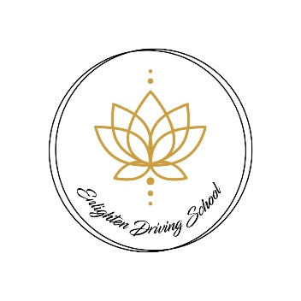**Enlighten Driving School**

**Terms and conditions**

You are required to provide full payment for lessons at least 48 hours prior to the lesson start time. Failure to do so will result in the lesson being cancelled and full payment required.

Payment for your first lesson must be completed via bank transfer in line with the above terms. If a pupil prefers cash payment this can be arranged following your completed first lesson.

You are required to give a minimum of 48 hours notice to Enlighten Driving School should you wish to change or cancel a lesson. Anything less than 48 hours and I will be required to charge you the normal lesson rate (or the prorated amount if it’s a block booking with discount).

All lessons purchased in bulk must be used within 3 months from purchase. After which period no refund will be payable.

In the unlikely event I am required to cancel or change your lesson I will provide as much notice as possible.

Punctuality: Please be punctual for your lesson time. I will wait a maximum of 10 minutes for you to arrive for your lesson, failure to comply with these timings will mean the lesson will be abandoned and full payment required. If I am delayed to your lesson for any reason outside of my control I will make the timing up at the end of your lesson if I am able to, or add it to another lesson.

There may be occasions where there is a requirement to change a pupils lesson due to test availability. In this case I will try and allocate you another slot if and where possible. However pupils with tests take priority.

It is your responsibility to present your valid UK provisional driving license before the start of your first lesson. Failure to do so entitles Enlighten Driving School to cancel any lessons you have booked and you may be charged.

Enlighten Driving School is entitled to change driving tuition offers and prices at any time and where possible notice of any changes will be provided.

In the event that you (the pupil) damage the car during the driving lesson or test, you will be required to pay for the damages to the car unless where an insurance claim is made.

As your instructor I am entitled to withdraw my car for the usage of your test, should I feel you are not ready. My decision on this will be final given my experience and responsibility as an Approved Driving Instructor.

As a pupil of Enlighten Driving School you agree to abide with the above Terms and Conditions. Should you have any dispute please contact me within one week of receiving these conditions and prior to any lessons commencing. Commencement of lessons demonstrates acceptance of the above terms and conditions.